Beneski Museum
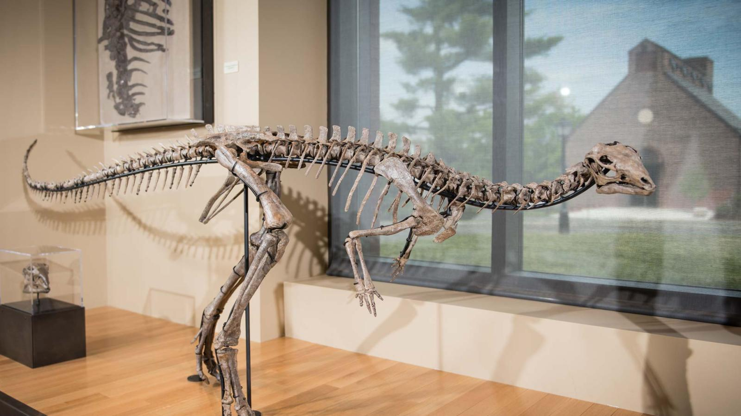

is one of New England’s largest natural history museums, featuring 3 floors of exhibits with more than 1,700 specimens on display.

FREE ADDMISSION

Tuesday, October 21, 2025

11 Barrett Hill Drive Amherst, MA 01002 P: 413-542-2165
  - Please RSVP by 10/14/25

  - Make sure to bring a packed lunch and wear good walking shoes.

